HIST 1110 (BHU) Class Time(s):
Dr. Julia Gossard Email: Julia.Gossard@usu.edu
Office Hrs: Office Location:

TA:
Office Hrs: Office Location: Main 321N

UTF: Cody Patton Email: Cody.Patton@aggiemail.usu.edu

COURSE DESCRIPTION:
The countries and cultures that make up “the West” share a common heritage, tradition, and certain values. This idea of a shared history and identity is why Western society has been much more willing to proclaim “#IamManchester” than “#IamInstanbul” in recent instances of attack. But, what exactly does it mean to be “Western”? What does it mean to be “modern”? What are the common elements that supposedly hold Western Civilization together? These questions will guide this survey course as we examine the development of modernity in “the West,” primarily EUROPE. We will examine the major political, social, economic, religious, and cultural movements that help to define the "modern" era in Western history. To better understand these movements, we will read a variety of primary sources including letters, treatises, declarations, images, material objects, maps, digital diaries, oral histories, and music. Topics covered include: The Enlightenment; The Age of Revolutions; The Industrial Revolution; Nationalism; Liberalism; The Rise of Mass Politics; Imperialism; World War I; World War II; The Cold War; Globalization; and the Clash of Cultures.

*Note: Except for Maus, this class will be experimenting with Open Education Resources (OERs) to provide a learning experience that is low-cost, accessible, and contributes to the advancement of open-access platforms in academia. The funding and support for this project is provided through the Merrill-Cazier Library. We will discuss what OERs mean, how their digital presentation can have an effect on learning, and whether or not the websites primary sources are hosted on have an impact on bias or credibility.

COURSE AND LEARNING OBJECTIVES:
Historical Knowledge
- Identify key events in the history of modern Europe from 1750 to 2001
- Describe the political, economic, social, and cultural elements of modernity in Europe
- Explain how race, gender, class, ethnicity, and religion influence historical structures and narratives
Historical Thinking
- Recognize both historical change as well as historical continuity
- Analyze competing, complex interpretations of historical events
- Extrapolate causation and understand multiple causation
Historical Skills
- Articulate well-written responses to historical prompts using appropriate evidence
- Assess the credibility and usefulness of primary and secondary sources
- Analyze primary sources to reflect larger trends in politics, economics, society, and culture
- Build digital literacy through a collaborative class Wiki
- Complete independent research
ASSIGNMENTS & ASSESSMENT
Class is both lecture and some discussion. Considerable time is spent developing students’ writing and analytical skills. Detailed instructions will be distributed. The following is an overview.

- 5% Participation & Preparation- Students are expected to attend all class meetings, well-prepared for the day’s discussion as active participants. Aim for at least one contribution to our discussions weekly. In-class exercises, like pop quizzes or small group work, will also be used to calculate participation scores.

ATTENDANCE POLICY: Excessive unexcused absences (more than 3) will cause a loss of all 5 points. More than 6 absences will result in a final grade of an F. Excused absences are only granted in the case of documented illness or emergency. The TA and Prof do not provide notes.

- 5% Syllabus Quiz - Due Sept 5 (Tues) – You must complete a quiz on the details of the syllabus regarding assignments, attendance, etc.
- 5% Primary Sources Quiz – Due Sept 7 (Thurs) – After reading “The Historian’s Toolbox: Primary Sources,” you must pass a quiz on primary sources.
- 20% Reading Grids (5 total; 4 best count), Due the day we read your primary source. You will pick ONE primary source from EACH unit. These reading grids are meant to help guide students’ analysis of primary sources. A grid template can be found on Canvas. Though there 5 units, only the best FOUR (4) grids will count. Plan wisely!
- 15% Food Timeline Online Group Project– By examining what people ate at different points in time, we can tell both what food was “in style” and also a lot about the economic conditions, social mores, political conflicts, religious issues, and nutrition. In small groups assigned by the instructor (or solo, if you choose), students will create a digital timeline of food throughout the Western world from roughly 1750 to 2001. Groups are responsible for 3 entries to the digital assignment over the course of the semester. These entries will be ~250-300 words. Entries can be food items (turnips, steak, spam, etc.), recipes, utensils, rations, agricultural innovations, or products. Additional instructions to come.
- 10% Maus Discussion Question & Participation – Art Spiegelman’s Maus, is a Pulitzer Prize winning graphic novel. It is a compelling story of the Holocaust and Holocaust survivors, written as a comic book. It uses humor and animal characters to talk about serious subjects like the Holocaust and depression. This assignment has three parts: 1) Read all of Maus; 2) Discussion Question - You will post this discussion question (due date based on alphabet) on Canvas by midnight the night before class starts. This question should not be a simple yes/no or fact-based question. Instead, it should foster critical thinking and analysis. In other words, we should be able to talk about it for at least a few minutes. No question should be repeated, so students must read the discussion entries of their classmates to ensure their question is original and will foster additional discussion. 3) Attend and participate in your discussion group.
- 20% Mid-Term Exam (Take Home)
- 20% Final Exam (Take Home)
Grading Scale: 93-100 (A), 90-92 (A-), 87-89 (B+), 83-86 (B), 80-82 (B-), 77-79 (C+), 73-76 (C), 70-72(C-), 67-69 (D+), 63-66 (D), 60-62 (D-), 59 or below (F)

Contacting Professor Gossard & TA, Office Hours, and Help at USU
If at any time during the semester you have a question, concern, or want to further discuss a topic that interested you in class, please come see Dr. Gossard or the TA during office hours or email one of us. (See first page for office hours, locations, and email).

Use office hours wisely – it’s a great way to get to get know your professor and TA outside of class (especially if you need letters of recommendation! ) and to get help if you are struggling with a particular concept. Office hours, however, are not to intended to be a review of a class you missed. If you are absent, get the notes from a friend (the professor, TA, and UTF do NOT provide notes) and do the assigned reading. We are happy to answer questions from a class you may have missed but we will not give an “overview” said class.

We will try to answer emails as soon as possible (no more than 24 hours during the week; no more than 48 on weekends). If our office hours do not work for your schedule, email me or the TA to set up an appointment.

USU has a number of centers and resources available to students:
- Academic Success Center (ASC) – Tutoring, Test Anxiety Management, Workshops
https://www.usu.edu/asc/
- Student Support Services (SSS) http://sss.usu.edu/
- Veteran’s Resource Center http://www.usu.edu/registrar/htm/veterans
- Counseling and Psychological Services (CAPS) http://counseling.usu.edu/
- Disability Resource Center http://www.usu.edu/drc/
- Student Health and Wellness Center http://www.usu.edu/health/

ADA, Honor Code, Civility, and Sensitivity Clause
- If you need any accommodation under the provisions of the ADA act, please inform Dr. Gossard as soon as possible.
- Students are expected to uphold irreproachable standards of academic integrity. In the event of any form of academic dishonesty (cheating, plagiarism, etc.) I will assign a score of 0 for the assignment. Repeated acts will result in failure of the course and a referral to the Dean of Students.
- Civility: Students are encouraged to speak their mind in the classroom, support each other, and even disagree with each other. But remember to speak to each other and your instructor with respect, even if you don’t agree with what the other has said. We will be discussing a number of controversial topics. Please be mature and respectful of others.
- Sensitivity clause: A number of our readings and class materials cover themes that some students may find to be disturbing or offensive. If you suspect that specific material is likely to be emotionally challenging for you, please contact Dr. Gossard as soon as possible for alternate reading and writing assignments. Furthermore, if during discussion of these topics, a student finds it emotionally challenging to be present during discussion, students may step out without academic penalty. Please alert Dr. Gossard if this occurs.

REQUIRED MATERIALS:
- To buy: Maus (Parts 1 AND 2) – Can buy separately or the combined volume.
- All primary source reading assignments except Maus are linked out on Canvas under “Modules.” All readings, except Maus, are considered Open Education Resources (OERs) that are provided free of charge to students.
- Some primary source “reading” assignments require you to analyze an image or listen to people’s oral history and testimony. If you are hearing or visually impaired, please contact me for an alternative assignment during those weeks.

CLASS, READING, & ASSIGNMENT SCHEDULE:
- Reading is due the day under which it is listed.
- Changes to this schedule will be communicated with students in-class, via email, and on Canvas. Check your email regularly.
Unit 1: Enlightening Revolutions
Tues 8/29: Introduction
Thurs 8/31: Enlightenment Thought
- Required Primary Source: Rousseau, “Social Contract Theory” (selections)*
- http://sourcebooks.fordham.edu/mod/rousseau-soccon.asp

Tues 9/5: Thomas Paine & The American Revolution
- Required Primary Sources: 1. Thomas Paine, “Common Sense”
- http://sourcebooks.fordham.edu/mod/paine-common.asp
- 2. “The Right of ‘Free Suffrage’”
- https://unitedstateshistoryto1877.files.wordpress.com/2013/01/the-right-of-free-suffrage-1776.pdf
PRIMARY SOURCE QUIZ IS DUE TODAY ON CANVAS BY 11:59PM

Thurs 9/7: The Coming of the French Revolution
- Required Primary Source: Abbé de Sièyes, “What is The Third Estate?”*
- http://pages.uoregon.edu/dluebke/301ModernEurope/Sieyes3dEstate.pdf
SYLLAUBS QUIZ IS DUE TODAY ON CANVAS BY 11:59PM

Tues 9/12: Rights of Man
- Required Primary Source: Declaration of the Rights of Man and of the Citizen*
- http://avalon.law.yale.edu/18th_century/rightsof.asp

Eugène Delacroix, “La Liberté guidant le peuple,” 1830


Thurs 9/14: LIBRARY INSTRUCTION DAY – MEET IN LIBRARY
AT LEAST ONE person per food group MUST attend the library instruction day.
FOOD GROUPS MUST STAKE THEIR FIRST CLAIM BY TODAY!

Tues 9/19: Napoleon’s Rise & Fall
- Required Primary Sources: 1. Selections from the Code Napoleon: http://www.historyguide.org/intellect/code_nap.html
- 2. Napoleon’s Account of the Internal Situation of France, 1804
http://history.hanover.edu/texts/NAPOLEON.html

Unit 2: The Nineteenth-Century Search for Order
Thurs 9/21: The Industrial Revolution
- Required Primary Sources: 1. Leeds Woollen Workers Petition
- https://sourcebooks.fordham.edu/Halsall/mod/1786machines.asp
- 2. Letter from Leeds Cloth Merchants
- https://sourcebooks.fordham.edu/Halsall/mod/1791machines.asp
- 3. William Radcliffe, “On Power Looms”
- https://sourcebooks.fordham.edu/Halsall/mod/1828looms.asp
- In-class: Excerpts from the Sadler Report

Tues 9/26: Liberalism and Conservatism in Europe
- Required Primary Source: Adam Smith, “The Principle of the Mercantile System”*
- https://sourcebooks.fordham.edu/Halsall/mod/1776asmith-mercsys.asp
FIRST FOOD TIMELINE ENTRY DUE BY 11:59PM

Thurs 9/28: Socialism and Communism
- Required Primary Source: Karl Marx, Communist Manifesto (selections)*
- http://iss.schoolwires.com/cms/lib4/NC01000579/Centricity/Domain/2863/AP%20-%20The%20Communist%20Manifesto.pdf
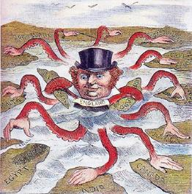

“Imperial Octopus,” 1888

Tues 10/3: Nationalism & 1848
Required Primary Source: Documents on German Unification, 1848-1871

Thurs 10/5: Asian Imperialism & the Opium War
- Required Primary Source: Commissioner Lin, Letter to Queen Victoria, 1839*

Tues 10/10: The Scramble for Africa and the Congo
- Required Listening (or Reading): Podcast, “15 Minute History, Episode 3: The Scramble for Africa” – Either listen or read the transcript (or both!) https://15minutehistory.org/2012/10/24/episode-3-the-scramble-for-africa/
In-Class Exercise: Imperialism in Africa – Maps, Photographs, and Cartoons

Thurs 10/12: Women’s Suffrage & Changing Experiences
- Required Primary Sources: Pick at least two sources from the following website on women’s suffrage in England* http://www.bl.uk/learning/histcitizen/21cc/struggle/suffrage/sources/sourcesintro.html
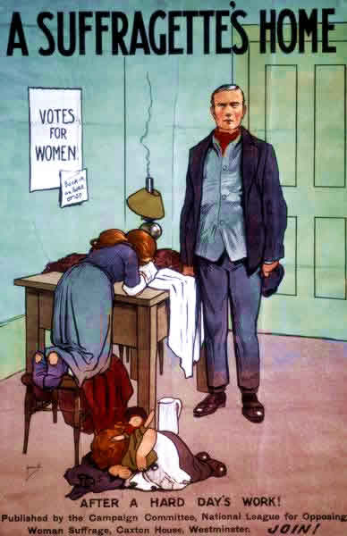

Anti-Suffragette Poster

Unit 3: The First World War
Tues 10/17: The Murder of the Archduke
- Required Primary Source: Borijove Jevtic, “The Murder of Archduke Franz Ferdinand at Sarajevo, 1914”*

Thurs 10/19 – FALL BREAK

Tues 10/24: Fighting a “Total War” & Internment
Required Primary Source: Minault, “In the Trenches,” (Diary) Pick 5 (five) days at random from September 22, 1914 to November 16, 1914
FOOD GROUPS MUST STAKE SECOND CLAIM BY TODAY!

Thurs 10/26: In-class Midterm Review

MIDTERM DUE ON CANVAS MON 10/30 by 11:59PM

Tues 10/31: The Russian Revolutions
- Required Primary Source: Voices of Revolution (excerpts)*
- Required Listening (or Reading): Podcast: 15-Minute History, Episodes 1 & 7
  - http://15minutehistory.org/2012/10/18/episode-1-the-february-revolution-of-1917/
  - https://15minutehistory.org/2013/01/03/episode-7-russias-october-1917-revolution/
  - Transcripts are available for each

Thurs 11/2: The End of WWI and the Rise of Fascism
- Required Primary Sources: Wilson’s Fourteen Points* and The Versailles Treaty*
- Required Primary Source: Benito Mussolini, “The Political and Social Doctrine of Fascism”*
SECOND FOOD ENTRY DUE BY 11:59PM

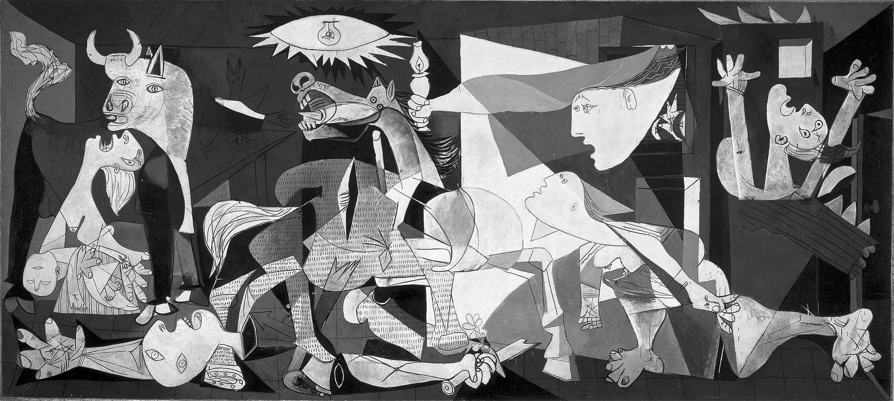
Pablo Picasso, “Guernica,” 1937
Unit 4: World War II
Tues 11/7: The Coming of The Second World War
- Required Primary Source: Adolf Hitler, Mein Kampf*

Thurs 11/9: The Holocaust & Experiences of War
- Required Oral History Sources: Fortunoff Video Archive for Holocaust Testimonies,* http://web.library.yale.edu/testimonies
  - Choose 2-3 videos to watch of people’s testimony. Some of the videos are quite long, but you should plan on watching about an hour.
  - Take note of the people’s descriptions, their emotions, and their memories.
  - Sensitivity Clause: These videos contain graphic descriptions and intense emotional responses at times. Please contact the professor if you are unable to complete the assignment for an alternative reading selection.

Tues 11/14: Maus, Discussion I
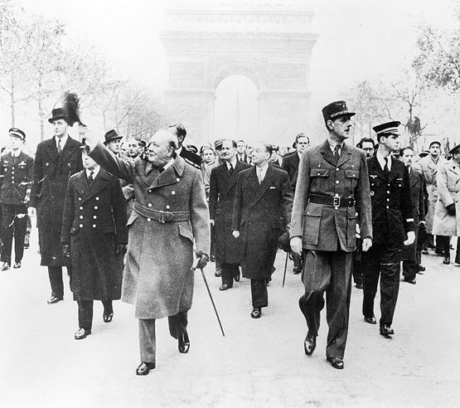
- Required Primary Source Reading: Read the entirety of Maus, Book I

Thurs 11/16: Maus, Discussion II
- Required Primary Source Reading: Read the entirety of Maus, Book II

The Liberation of Paris
(Churchill and de Gaulle)

Tues 11/21: The Allied Counterattack & The End of WWII
FOOD GROUPS MUST CLAIM LAST ENTRY BY TODAY!
Thurs 11/23: THANKSGIVING BREAK

Unit 5: The Cold War Era & Beyond
Tues 11/28: From Reconstruction to Confrontation: The Origins of the Cold War in Europe
- In-Class Exercise: Political Cartoons – “The Iron Curtain” and “The Marshall Plan”
- Required Primary Source: Truman’s Press Release on the Dropping of the Atomic Bomb, August 6, 1945 found at the Truman Presidential Library: https://www.trumanlibrary.org/whistlestop/study_collections/bomb/large/documents/index.php?documentid=59&pagenumber=1

Thurs 11/30: The Beatles in Berlin: 1960s Counterculture & Cold War Thaw
- Required Primary Source: 1) Listen to music clips posted on Canvas of rock n’ roll *
- If you are hearing impaired, please contact me for an alternative primary source assignment.

Tues 12/5: Fall of the USSR & Globalization
THIRD FOOD ENTRY DUE BY 11:59PM

Thurs 12/7: The West Recast & Review
PEER REVIEW DUE BY 11:59PM

TAKE-HOME FINAL EXAM DUE ON CANVAS TBD

